EPK – LOGAN J PARKER

“Logan J Parker has that WOW factor, her music blends the guitar skills of Memphis Minnie and the vocal emotion of "Empress of the Blues", Bessie Smith on her heartfelt original material - this lady catches the ear and the heart” - Clive Richardson

— Maritime Radio

Logan J Parker is a North London based singer, songwriter, producer, guitarist and pianist. Her compositions are a blend of old Blues, Soul and 60's Rock and Roll with a touch of modern day sophistication. Logan is part of Extinction Rebellion's musical arm Music Declares Emergency and her EP was recorded in the world's first fully solar powered studio. She is an ambassador for Super Soco UK, Bohemian Guitars US and Vintage Guitars UK. With regular plays on BBC Radio London, Kent and Essex as well as Atlantic Radio UK, Pulse FM, Gorgeous FM and Amazing Radio, among many others, she's also played live on Portuguese television. Fiercely independent and a copyright owner, Logan is ready to take the world by storm.

BIO

Logan J Parker was born in Portugal. Influenced by the sea and sun, her hometown
Ericeira holds a special place in her heart, she states, “I learned to surf before I started to walk. My parents were my music gurus, they played me and my siblings the most amazing records one can only imagine.”

She has diverse musical influences from T Bone Walker to Leonard Cohen inspiring her love for early Mississippi Blues to 50's Jazz, 60's Rock n' Roll and later her most recent influences such as Amy Winehouse, The Teskey Brothers, Kaleo, and Melody Gardot.

“When I look back at my childhood I recall vinyl everywhere, long walks on the beach, endless sunny days, laughter and tears. Music was a natural state of mind. It was my safe place and so, while growing up, it became an essential part of me.”

Once she graduated in Economics, she moved to work in a bank in Lisbon which she began to hate, she states, “I found myself so creatively restricted and stripped of all my hopes and dreams, to the point that I got really ill. One day I collapsed in the bank and at the hospital, I was first diagnosed with leukaemia, which thankfully turned out to be chronic anaemia. The shock helped me realize that life is precious and we can’t waste time living
an unhappy and unfulfilling life. Since that day, I decided to choose music...forever. Like Bukowski says: You have to die a few times before you can really live.”

This led Logan to move to London in 2015 when she began to work on her own music, composing originals. After meeting Viv Broughton, CEO in The Premises Studios while recording her demo, things started happening and led to the release of her debut EP in September 2019.

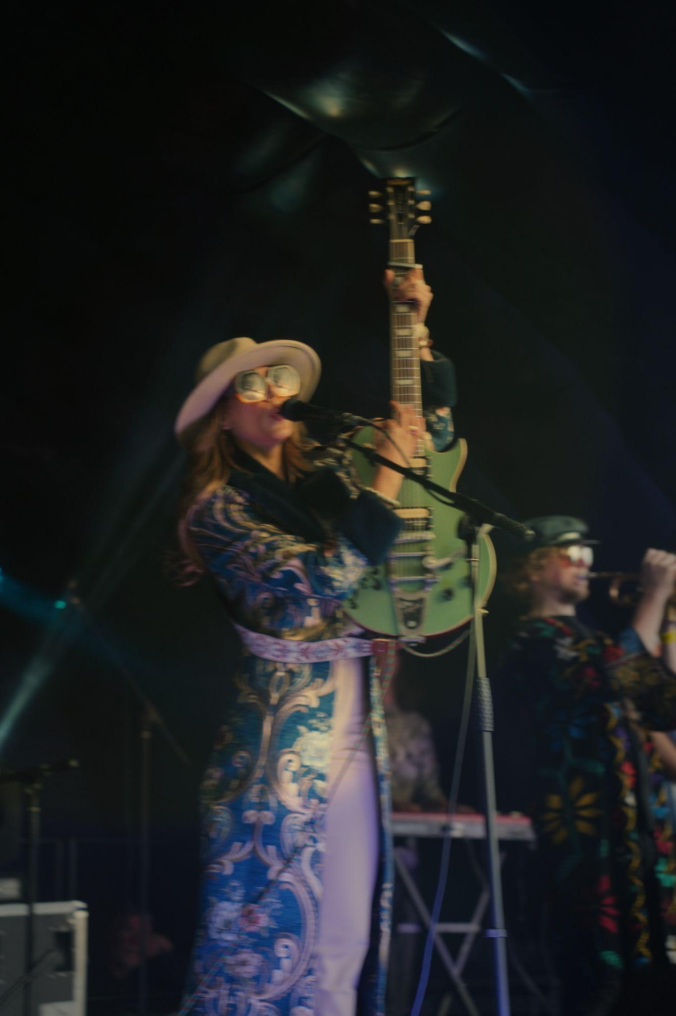
Logan supports the Extinction Rebellion movement so she makes her records in a fully solar-powered studio. She believes in artist empowerment, especially for women. She creates her music through her own independent company where she owns all her copyright. She states, “It’s outrageous that music artists are still forced to sign their lives away for a pittance – look at Taylor Swift, all her copyrights now owned by her worst enemy!”

Her single ‘Cry Cry Cry’, which she wrote, composed, and produced, is out now from her debut self-titled EP. The music video was shot in Camden Town, London, a place she has been fond of since her arrival in the United Kingdom. She dedicated the song to all musicians, stating, “I wrote this song out of my deepest sadness for being a musician and being in a constant struggle for survival.” She has a defining trait of a singer-songwriter’s personality with the ability to be perfectly honest about her feelings and views of society.

Logan was very productive during the Lockdown and released two new singles which are 100% home-made: 'We'll Be Gone' and 'Blue'. The former grabbed the Portuguese media's attention and Logan went live on the news to talk about her Lockdown experience in London, this brought her a wide and unexpected exposure which has translated into new fans and followers. The latter was released on the 10th of May, a song she dedicated to her mother Rita on mother's day.

Her single 'My Faith is Hard to Follow', is a haunting summer breeze of a song laden with echoes of Billie Holiday and Ella. The video - a surfer’s mini-odyssey - was shot and edited entirely on Logan's own iPhone, filmed by her Mum Rita! As so often with Logan’s songs, underneath each sparky hook lurks a deeper darker lyric. ‘My Faith Is Hard To Follow’ might swing like crazy but behind the curtain, heartbreak and betrayal are never too far away. Another classic gem from Logan J Parker!

Logan J Parker has built up a reputation for doing things differently and her Christmas release is no exception. Released on Christmas Day - when nobody releases anything EVER - 'Sweet Songs Of Love' is a festive heart-breaker in two parts. The languid opener sets verse and chorus up like a love letter, a yearning vocal over a sumptuous wash of bluesy guitars before it picks up the backbeat and a succession of raw soaring choruses lift the song to its zenith. Trigger warning - this one will stick in your brain like super-glue.

The Walking Alone music video portrays a young woman walking through the empty streets of London alone, her mind elsewhere. It could have been this week, or any week, but 'Walking Alone' is a song that has special resonance now, when the simple act of walking unaccompanied through the metropolis seems like a gesture of defiance. Logan J Parker's huge gritty ballad is a tense heart-breaker that could not have come at a more appropriate moment.

Her latest release Where Nobody Goes is a love song to her electric motorcycle.

Logan is a star in the making. Her original songs come deep from her soulful heart. She is currently working on her debut album which is due for release in 2024.

MUSIC VIDEOS

WHERE NOBODY GOES https://www.youtube.com/watch?v=1WupO_U1stc

WALKING ALONE https://youtu.be/MyFNkDvaj_k

SWEET SONGS OF LOVE https://youtu.be/GfhjIakNl6Y

MY FAITH IS HARD TO FOLLOW https://youtu.be/dYOZG4VXnBI

BLUE https://youtu.be/e1NyrDvGkWk

WE'LL BE GONE https://youtu.be/fIDBvXZRwuQ

CRY CRY CRY https://youtu.be/MzN6cTGCBTo

I DON'T WANNA GO https://youtu.be/cGrNQfcUsSo

LOVE IS JUST A MOMENT https://youtu.be/5zYfnxyiY30

STREAMING

https://open.spotify.com/artist/7jUwwtZRSkFICXe6rLQu6B

ON TV

SWEET SONGS OF LOVE - TV LIVE PERFORMANCE (UNPLUGGED) https://youtu.be/ZxpfV4DJVr4

SWEET SONGS OF LOVE - PERFORMANCE AND INTERVIEW
https://youtu.be/IOOoUodu5VM

LIVE ON THE NEWS - PORTUGUESE NATIONAL TELEVISION https://www.facebook.com/watch/?v=408134447292968

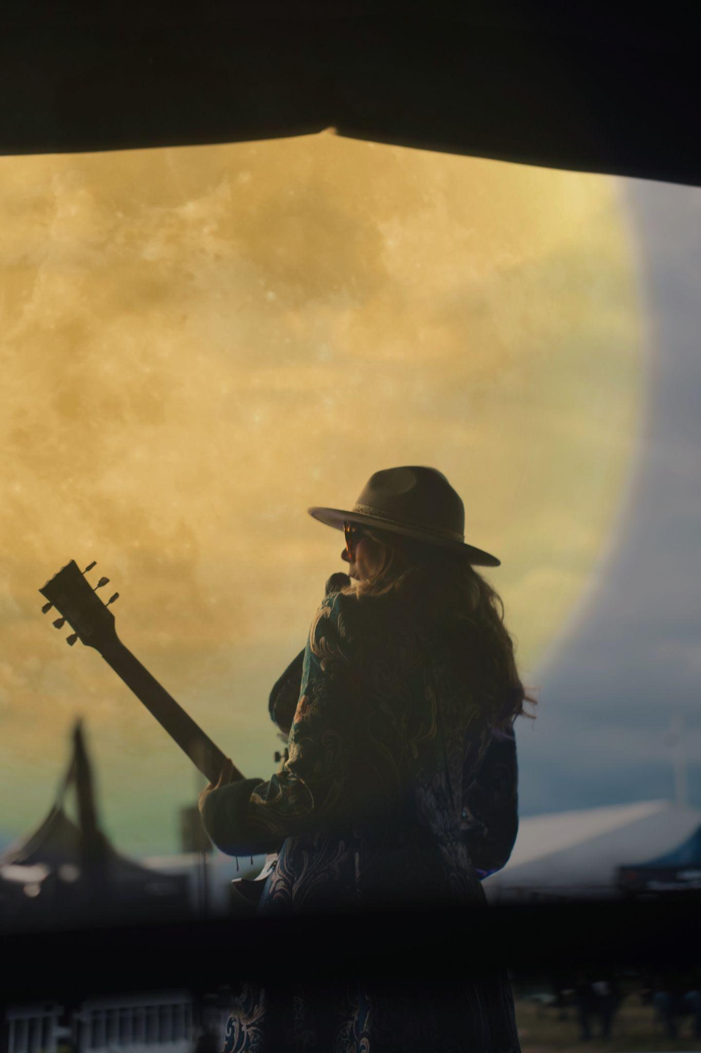

PRESS

https://camden-live.com/interview-logan-j-parker-how-an-oil-can-guitar-brought-her-back-from-heartbreak/?fbclid=IwAR3qRHDnqa4siBkIT4KFa3lwnKI7Rs4UkiFYJsI1GN72gNO7x8kcsrtDCBQ

https://listenwithmonger.blogspot.com/2021/01/logan-j-parker-single-review.html?m=

1

https://podcasts.apple.com/gb/podcast/ep-29-logan-j-parker/id1508092324?i=1000500478070&fbclid=IwAR2ksos20mkORzVaS1oFkK_D9m00K1zZqOAcpFOguHFBEi2cdUQb15ghP9I

https://www.thenowlegacy.com/post/introducing-logan-j-parker-the-now-legacy?fbclid=IwAR1iIBbF1R0fh4XXee3xOtTZGyRMgkeXcdng8BfPqZ4XrCqKOG6MBiK2WGM

https://www.puremzine.com/logan-j-parker-sweet-songs-of-love-single-review/?fbclid=IwAR0cs7oH-Zp3GFM99t6G9w1sRtV3Dx3rj1FAodV5cQJNkDjR2Ugo0TDFq3o

https://loganjparker.com/sweet-songs-of-love-the-music-below-article

https://loganjparker.com/starrymag-interview-sweet-songs-of-love

https://loganjparker.com/jammerzine-sweet-songs-of-love-article

https://loganjparker.com/sweet-songs-of-love-review-by-erin-servey-soft-sound-press

https://rawramp.me/2021/01/15/logan-j-parker-ljparkermusic-brings-sweetsongsoflove-to-a-fractured-universe-londonengland-songwriter/?fbclid=IwAR2qMDmmEQGS-eIY89K6SdjTwdm9NERSDqbbKFAK58WmlUHru24qgCy4y5U

BBC RADIO LONDON https://www.youtube.com/watch?v=l4wBN0WAFtM&t=4s

https://dshowmusic.com/logan-j-parker-bohemian-honey-oil-can-guitar/

https://www.musicinstrumentnews.co.uk/2020/12/02/logan-j-parker-goes-bohemian-with-christmas-single/?fbclid=IwAR2zCYGmUojGptxz-sU7LdCCiglTaMsJ2lUM63K2-uCAU3PaXjfzfWnXhjE

https://www.mixcloud.com/soelvyra/the-cure-14122020-christmas-special/?fbclid=IwAR1vyb4ll-yEuhGrgSy15m1gIb3KxGhgxoqVmIRRAI_UaT7k1FnWDSht9rk

LIVE ON THE NEWS - PORTUGUESE NATIONAL TELEVISION https://www.facebook.com/watch/?v=408134447292968

http://www.unclearmag.com/music-posts/2020/12/14/logan-j-parker-interview?rq=Logan%20Parker&fbclid=IwAR1AlxgG3Ug38zklYa9Tqje-1BsG1D2RFH2x5SSLHa6IsrEwh4XwqkuHf20

BRITAIN’S RARE GUITARS LIVE INTERVIEW https://www.youtube.com/watch?v=Fqxzzd-6ngs&feature=youtu.be

https://www.puremzine.com/logan-j-parker-sweet-songs-of-love-single-review/?fbclid=IwAR2TItHXETwmWruY8yffp1Vss5bCK9z5qCR9_whRAFFix0JS7ZTarEsjllo

https://newnoisemagazine.com/premiere-logan-j-parker/

https://anchor.fm/tapetevermelho/episodes/Logan-J-Parker-de-Londres-para-o-Brasil-ed1q2o

https://www.mixcloud.com/audreyslatenightdrive/audrey-hall-with-logan-j-parker-yemi-botalawi-pt2-audreys-early-drive-allfm-17-sept-2020/?fbclid=IwAR2bbP9ROcw2NXjDCyNU0dM4Q7IvBca_LQBDW8-fXt1AiszdU8jZyUTlGqQ

https://www.mixcloud.com/djrcreative/the-dave-rhodes-radio-experience-2020-show-24-2550620-logan-j-parker-special/?fbclid=IwAR1N9EWMCSvvg_yPGEPC3jp2QF_e2KX6Yc1eSQIHCbK06ZHa_pGW8YNnQj0

https://www.youtube.com/watch?v=aM1Pyl54TaA&t=39s

https://loganjparker.com/daily-dose-logan-j-parker-sweet-songs-of-love-by-ryan-martin

https://www.rtp.pt/noticias/cultura/covid-19-portuguesa-logan-j-parker-compos-musica-inspirada-na-pandemia_v1222811

https://www.naludamagazine.com/interview-with-talented-london-based-songstress-logan-j-parker/

https://bayviewsounds.blogspot.com/2020/05/logan-j-parker-cry-cry-cry-single-review.html?fbclid=IwAR3mWzZxahD8VNA_4bNgpFErE3N7zZiYJfFJ-Tsqr7A8O-3ARFhOLu_Armg

https://loganjparker.com/ep-review-emma-schoors-unclear-mag

https://loganjparker.com/single-review-dave-mcmahon-bayview-sounds

https://loganjparker.com/whytt-magazine-article

https://loganjparker.com/unclear-magazine-interview

https://loganjparker.com/single-review-we-ll-be-gone

https://loganjparker.com/interview-for-puremzine-by-danielle-holia

n https://loganjparker.com/album-review-by-danielle-holian

https://loganjparker.com/maritime-radio-interview-by-clive-richardson-1

https://loganjparker.com/maritime-radio-interview-by-clive-richardson-2

CONTACT AND WEBSITE

Logan J Parker loganjparkermusic@gmail.com

www.loganjparker.com

